The Anthropologist (T-Anth)
Received on 08. 09. 2014
REF. NO. T-ANTH-188-14
(Always refer our Reference No. for all correspondence)
Detection of The Effects of Sodium Bicarbonate Supplement on Blood Lactate and Heart Rate Values of Female Futsal Players Before and After Yo-Yo/1 Test
Mihri Barış Karavelioğlu
School of Physical Education and Sports, Dumlupınar University, Kütahya, Turkey

Detectıon of the Effects of Sodıum Bıcarbonate Supplement on Blood Lactate and Heart Rate Values of Female Futsal Players Before and After Yo-Yo/1 Test

Mihribarış Karavelioğlu

School of Physical Education and Sports, Dumlupınar University, Kütahya, Turkey
E-mail: mbariskaravelioglu@dpu.edu.tr

KEYWORDS Female Futsal, Sodium Bicarbonate, Heart Rate, Yo-Yo/1

ABSTRACT The major aim of this study is to examine the effects of sodium bicarbonate supplement on the blood lactate and heart rate values of female futsal players before and after Yo-Yo/1 test. Fifteen (15) futsal players in 20.53 ± 1.70 year age range, 166.93 ± 4.87cm height range and 61.06 ± 2.49kg body weight range participated as the experimental group, while 14 futsal players in 21.00 ± 1.46 year age range, 166.86 ± 6.10cm weight range and 68.57 ± 4.62kg body weight range participated as the control group voluntarily in the present study. The blood samples collected from fingertips helped a lot, while blood lactate values of the athletes were measured before and after Yo-Yo/1 test. Heart rate values of the participant athletes were recorded using polar watch during the test. Paired sample t-test was used to detect the differences between the pre-test and post-test blood lactate, heart rate (HR) and maximal running distance values of the participating athletes. The difference between the post-exercise blood lactate and maximal running distance values of the participant female futsal players was found to be significant (p < 0.05).

INTRODUCTION

Futsal is the five-a-side version of football usually played indoors on a smaller pitch. It is played by over a million registered players worldwide and is a growing sport in many countries. It started in South America in 1930 and, the first World Futsal Championship was held 1982 in Brazil. Since 1989, a Futsal World Cup has always been organized by the Federation Internationale de Football Association (Junge and Dvorak, 2010).
Futsal is different from indoor football (indoor soccer), which is more common in the USA and Canada. The most important differences are that a team includes six players, and the ball can be played directly off the wall that surrounds the playing field. (Hoffand Martin1986, EmeryandMeeuwisse, 2006)In fact, compared with soccer, the technical proficiency of a futsal player is strongly influenced by the smaller ball with 30% less bounce, which forces the players to develop the ability to accurately control and move the ball quickly on the ground (Benvenuti et al., 2010). Furthermore, the reduced pitch dimensions and the frequent turnovers during futsal match-play require the players’ fast decision-making and high sprint capabilities under pressure during both attacking and defending phases (Vaeyens et al. 2007).
From the analyses of heart rate and time–motion during competitive matches, the authors concluded that futsal is a multiple-sprints sport with more high-intensity phases than football (Castagna et al. 2009). The presence of athletes showing high-performance as well as high technical capacity constitutes an important advantage over the rivals in futsal. Theoretically, a nutritional intervention could augment high-intensity interval training adaptation by improving energy metabolism during exercise, which could facilitate greater total work and an enhanced chronic training stimulus, or promoting some aspect of the adaptive response during recovery, which could lead to enhanced physiological adaptations over time (Gibala, 2013). One of the supplements widely used to improve performance is sodium bicarbonate. In recent years, there has been widespread use of ergogenic aids (Gledhill, 1984). The supplementation of sodium bicarbonate (NaHCO3) could increase performance or delay fatigue in intermittent high-intensity exercise (Wu et al., 2010).
Alkalinizing agents, including sodium bicarbonate (NaHCO3) have been regarded as ergogenic aids because of their ability to provide enhanced extracellular buffer capacity, which leads to elevated proton (H+) efflux from the contracting musculature (Matson and Tran 1993, Requena et al., 2005). The increased intramuscular [H+] during exercise has been considered as one of the major causes of muscle fatigue (Fitts, 1994). The bicarbonate ion (HCOf) is an effective intracellular buffer, and the efflux of H+ ions from cells is accelerated by augmenting the extracellular buffer. It has been hypothesized that it may be possible to enhance anaerobic performance by offsetting the fall in intracellular pH during exercise by increasing the bicarbonate reserve prior to exercise (Hirche et al., 1972, Mainwood and Lucier 1972).
In addition to be highly related to match performance, Yo-Yo test is one of the tests used most commonly in evaluation of athlete performance. Yo-Yo intermittent recovery test level 1 (Yo-Yo IR1) is the most utilized test for monitoring a player’s ability to cope with intermittent exercise in team sports (Bangsbo et al., 2008). Yo-Yo intermittent recovery test is also used to evaluate an individual’s capability to continue a repetitive high-intensity exercise (Delahunt et al., 2013; Bangsbo et al., 2008). In the scope of Yo-Yo test, each participant performs 20-meter shuttle run with one recovery period between two subsequent runs. Thus, Yo-Yo test is an intermittent test consisting of progressive 2x20-m shuttle runs intermitted by a 10-second active resting period. The participant runs till exhaustion and the distance covered till that point is recorded as the test result (Bangsbo et al., 2008).
The aim of this study is to examine the effects of sodium bicarbonate supplement on the blood lactate and heart rate values of female futsal players before and after Yo-Yo/1 test.

MATERIAL AND METHODS

Fifteen (15) female futsal players within 20.53 ± 1.70 year age range, 166.93 ± 4.87cm height range and 61.06 ± 2.49kg body weight range participated as the experimental group, while 14 female futsal players in 21.00 ± 1.46 year age range, 166.86 ± 6.10cm weight range and 68.57 ± 4.62kg body weight range were voluntarily used as the control group in the study. Participants were randomly assigned to two groups of which are experimental group and control group.
Two hours before the experiment, the experimental group was given bicarbonate (0.3 g/kg body weight) supplement and the control group was given placebo with water using double blind system, but both groups were on a full stomach. Measurements were made at the end of the preparation stage of the team and out of menstruation periods of the participants. Before the study, all athlete were informed about the measurements and she/he was asked to sign an informed consent form including information on possible risks and disturbances. The participants were asked to abstain from heavy exercise in the last 24 hours before the measurements.

Endurance Test

Yo-yo 1 interlaced recovery test which is developed by Bangsbo (1994) is used to define participant sportsmen’s endurance capacity. Yoyo test is a test which has 10 seconds active relaxation period between 2X20 meters sit-up running at acceleration speed. In the scope of the study, the test was applied at a 20-meter lane. Athletes’ 10-second break area was determined by a 5-meter line marked behind the starting point. Athletes were informed before the test and all tests were performed in synthetic turf football field.

Heart Rate Measurements

Athletes’ heart rate values before, during and after the Yo-Yo/1 test (resting pulse) were determined using a polar watch (Polar RS 800CX Heart Rate Monitor, Finland). Heart rate monitor consists of a receiver watch worn on the wrist and connected through radio waves and a transmitter chest strap. Chest strap transmits heart rate values to the watch at 5 second intervals in order to monitor heart rate values. At the end of the study, the data of the participants, which are already in the monitor’s memory were transferred to the computer software program (Polar ProTrainer 5 Professional Training Software for Windows), using the USB-external infrared receiver.

Blood Lactate Measurements

Blood lactate value was measured using Eco Twenty Care Diagnostica lactate analyzer. In the scope of the lactate measurements; blood samples obtained by lancet via finger prick method were collected into the double-bore 20 µl capillary tube which has no air hole in it. Blood samples collected in the capillary tubes were put for blood analysis in the 2.0 ml covered plastic sample dish containing disruptive agents and, the cover was firmly closed. The plastic sample dish was shaken by hand to diffuse the blood in the capillary tubes into the solution in the plastic dish. Then, the samples in the plastic sample dish were placed in the numbered boxes in the lactate analyzer tray. The device was calibrated using the 1.62 and 3.36 mmol.l-1 standard concentration lactate solutions in the 2.0 ml tubes provided by the manufacturer. After completion of the calibration process, measurement process was completed by the device.

Statistical Analysis

Paired sample t-test was used to detect the difference between the blood lactate, heart rate and maximal running distance values of the athletes who participated. Measurements were statistically analyzed using SPSS 17.0 for Windows and, statistical significance was set at P<0.05.

DISCUSSION AND CONCLUSION

While there are some studies addressing NaHCO3 supplement as an ergogenic in athletes and showing positive effects of such use on athlete performance, there are some other studies which do not reveal such effect (Koca, 2004).
Findings of the present study, on the other hand, showed that NaHCO3 reduces blood lactate levels and increases the distance run by the individu als and that heart rate response obtained during an exercise at a specific intensity level reduces, though not at a statistically significant level, after sodium bicarbonate loading. In other related studies, athletes of different sports branches have been loaded with NaHCO3 within a 100 mg/kg - 300 mg/kg dose range in order to examine its effects on short-term exercise.
In the light of the results they obtained, Verbitsky et al. (1997) suggested that acute NaHCO3 consumption may have an effective role on torque strength increase during isometric muscle contractions and, for this reason, shortens recovery period by reducing fatigue. In their study called “Effect of Beta Alanine and Sodium Bicarbonate Supplementation on Repeated-Sprint Performance”, Ducker et al. (2013) revealed the positive effects of sodium bicarbonate supplement on 20-meter speed values of athletes. The study conducted by Wu et al. (2010) on tennis players stated that sodium bicarbonate supplement prevents a low match performance of athletes.
Zajac et al. (2009) stated in their study on young swimmers that sodium bicarbonate is a good buffer for high-intensity exercises and Meo et al. (2013) revealed in their study on swimmers that the concerned supplement has a good buffer effect on maximal interval swimming exercises of less than 60 seconds. In the study of rowing athletes, Hobson et al. (2014) detected positive effects of sodium bicarbonate supplement on the performance of athletes. The present study also showed that increased running distance achieved by the female futsal players is an indicator of performance improvement.
Matthew et al. (2013) conducted a study on cyclists, which showed that NaHCO3 has a reducing effect on blood PH level (7.42±0.02 to 7.39±0.02). The study made by Henning et al. (2002) on the effects of NaHCO3 on the blood lactate levels of the rowing athletes in short-time exercise produced pre-exercise and post-exercise blood lactate levels of 1.0±0.2 and 16.2±1.2 mmol/L for the placebo group and of 0.9±0.1 and 25.7±2.1 mmol/L for the experimental group, respectively. Researchers suggest that the positive effect of NaHCo3 on short-term high-extensive exercise is the removal of H+ from the accumulating medium in the working tissue, reduction of intracellular pH level and prevention of over exhaustion. Therefore, NaHCO3 supplement reduces blood lactate level, which negatively affects the performance of an athlete. The present study also revealed reduced blood lactate levels.
In conclusion, it can be suggested that NaHCO3 can reduce blood lactate levels of female futsal players, thereby increasing the distance covered by the athlete during a race and so is effective on blood rate at the end of Yo-Yo/1 test.
RESULTS

Table1. Physical Properties of the Participants

Variables | N | Experimental |  | N |  | Placebo
Variables | N | Average ± sd |  | N |  | Average ±sd
Age (year) | 15 | 20.53 ± 1.70 |  | 14 |  | 21.00 ± 1.46
Height (cm) | 15 | 166.93 ± 4.87 |  | 14 |  | 166.86 ± 6.10
Body Weight (kg) | 15 | 61.06 ± 2.49 |  | 14 |  | 68.57 ± 4.62

Average age, height and body weight values of the experimental group athletes were found to be 20.53 ± 1.70 years, 166.93 ± 4.87 cm and 61.06 ± 2.49 kg, respectively, while that of the placebo group athletes was found to be 21.00 ± 1.46 years, 166.86 ± 6.10 cm and 68.57 ± 4.62 kg, respectively.

Tablo2. Pre- and Post-Exercise Blood Lactate Values of the Participants
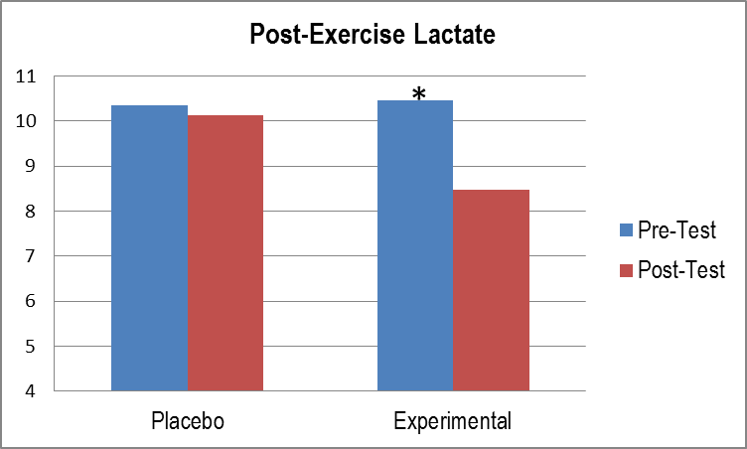
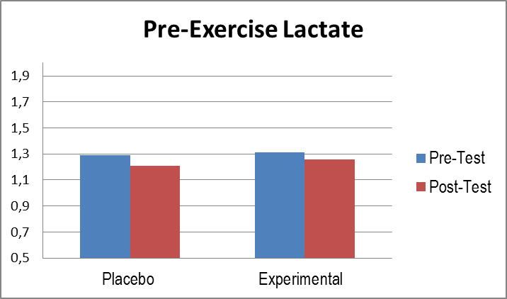

Examination of the pre-exercise blood lactate levels produced no statistically significant differences between the average pre-test blood lactate values (1.29 ± 0.23) and post-test blood lactate values (1.21 ± 0.09) of the placebo group. Similarly, no statistically significant difference was found between the average pre-test (1.31 ± 0.20) and post-test (1.26 ± 0.15) blood lactate values of the experimental group.
Inspection of the post-exercise blood lactate values revealed no statistically significant difference between the average pre-test blood lactate values (10.34 ± 2.14) and post-test blood lactate values (10.12 ±1,20) of the placebo group. However, statistically significant difference was found between the average pre-test (10.46 ± 1.87) and post-test (8.48 ± 0.82) blood lactate values of the experimental group.
Table3. Pre- and Post-Exercise Heart Rates (HR) of the Participants
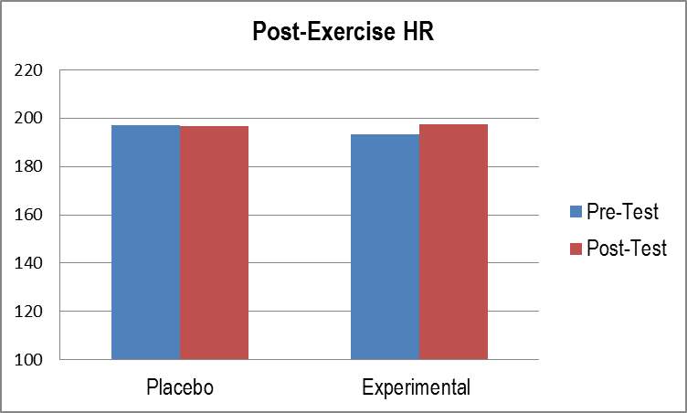
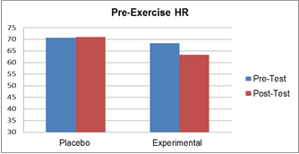
In terms of the pre-exercise heart rate values; no statistically significant difference was revealed between the average pre-test heart rate values (70.64 ± 6.41) and average post-test heart rate values (71.00 ± 4.96) of the placebo group. Similarly, there was no statistically significant difference between the average pre-test (68.26 ± 4.63) and post-test (63.26 ± 13.73) heart rate values of the experimental group athletes.
In terms of the post-exercise heart rate values; no statistically significant difference was revealed between the average pre-test heart rate values (197.21 ± 6.22) and average post-test heart rate values (196.85 ±7.06) of the placebo group. Similarly, there was no statistically significant difference between the average pre-test (193.46 ± 6.86) and post-test (197.40± 4.96) heart rate values of the experimental group athletes.

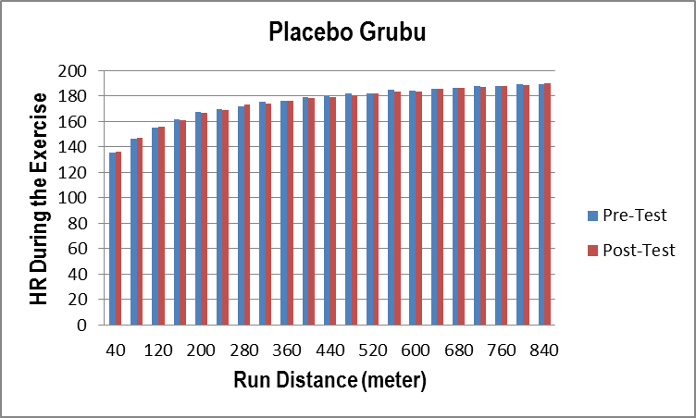
Table4. Heart Rate (HR) of Participant Athletes during the Exercise
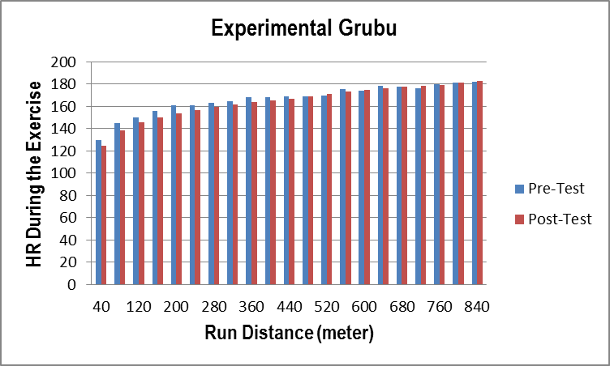

While no statistically significant difference was found between the pre- and post-exercise heart rate values of the placebo and experimental group participants, examination of the heart rate responses given during the exercise in proportion with the distances run showed that post-test values were low in the experimental group, particularly at the beginning of the exercise, whereas no such difference was revealed between the pre- and post-test values of the placebo group. This result points that sodium bicarbonate results in reduced heart rate during the exercise, therefore, is effective in the improvement of performance.

Table5. Maximum Distance Run by Participants in Yo-Yo/1 Test
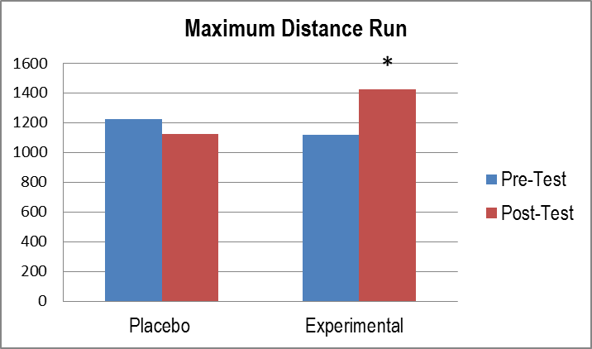

Comparison between the average pre-test (1222.85± 212.65) and post-test (1122.85± 238.17) running distances of the placebo group athletes produced no statistically significant difference, while a statistically significant difference was found between the average pre-test (1120.00 ± 320.35) and post-test (1421.33± 287.59) running distances of the experimental group.

REFERENCES
- Bangsbo J, Iaia M, Krustrup P 2008. The Yo-Yo Intermittent Recovery Test. A Useful Tool for Evaluation of Physical Performance in Intermittent Sports. Sports Med,38:37-51.
- Bangsbo J 1994. The physiology of soccer with special reference to intense intermittent exercise. Acta Phys. Scand., 151, Suppl. 619: 155.
- Benvenuti C, Minganti C, Condello G, Capranica L, TessitoreA 2010. Agility assessment in female futsal and soccer players.Medicina (Kaunas), 46(6):415-20.
- Castagna C, D’Ottavio S, Granda Vera J et al 2009. Match demands of Professional Futsal: a case study. J Sci Med Sport, 12 : 490 – 4.
- Delahunt E, Callan L, Donohoe J, Melican R, Holden S 2013. The Yo-Yo intermittent recovery test level 1 as a high intensity training tool: Aerobic and anaerobic responses. Preventive Med, 56: 278-282.
- Ducker KJ, Dawson B, Wallman KE 2013. Effect of Beta Alanıne And Sodıum Bıcarbonate Supplementatıon On Repeated-Sprınt Performance, Journal of Strength and Conditioning Research, 27(12)/3450–3460.
- Emery CA, Meeuwisse WH 2006. Risk factors for injury in indoor compared with outdoor adolescent soccer. Am J Sports Med, 34:1636-42.
- Fitts RH 1994. Cellular mechanisms of muscle fatigue. Physiol Rev,74:49-94.
- Gibala MJ2013. Nutritional strategies to support adaptation to high-intensity interval training in team sports. Nestle NutrInst Workshop Ser.;75:41-9. doi: 10.1159/000345817. Epub 2013 Apr 16.
- Gledhill N1984. Bicarbonate ingestion and anaerobic performance. Sports Medicine, 1, 177-80.
- Henning B, Nelsen P, Bremose M 2002.Bikarbonate attenuates arterial desaturation during maximal exercise in humans. J ApplPhysiol, 93:724-731.
- Hirche H, Hombach V, Langhor HD and Wacker U 1972. Lactic acid permeation rate in working skeletal muscle during alkalosis and acidosis. PflügersArchiv, 332, R73.
- Hobson RM, Harris RC, Martin D, Smith P, Macklin B, Elliott-Sale KJ, Sale C 2014. Effect of sodium bicarbonate supplementation on 2000-m rowing performance, Int J Sports Physiol Perform, Jan; 9(1):139-44. doi: 10.1123/ijspp.2013-0086.
- Hoff GL, Martin TA 1986. Outdoor and indoor soccer: injuries among youth players. Am J Sports Med, 14:231-3.
- Junge A, Dvorak J 2010. Injury risk of playing football in Futsal World Cups. Br J Sports Med,44:1089–1092.
- Koca F, Süer C, Erol E 2004. The Ergogenic Effect of the Sodium Bicarbonate on Short Term High Intensity Anaerobic Exercises in Which are at Different Altitude, E.Ü.Journal of Health Science, 13(2) 39-45.
- Mainwood GW and Lucier GE 1972. Fatigue and recovery in isolated frog sartorius muscles: The effects of bicarbonate concentration and associated potassium loss. Canadian Journal of Physiology and Pharmacology, 50, 132-42.
- Matson LG, Tran ZV 1993. Effects of sodium bicarbonate ingestion on anaerobic performance: a meta-analytic review. Int J Sport Nutr,3:2-28.
- Meo AA,Hirvonen P,Saarela J,Hulmi JJ,Hoffman JR, Stout JR 2013. Effect of sodium bicarbonate and beta-alanine supplementation on maximal sprint swimming, Journal of the International Society of Sports Nutrition, doi:10.1186/1550-2783-10-52.
- Northgraves MJ, Peart DJ, Jordan CA, Vınce RV 2014. Effect of Lactate Supplementatıon and Sodıum Bıcarbonate on 40-km Cyclıng Tıme Trıal Performance, Journal of Strength and Conditioning Research, 28(1)/273–280.
- Requena B, Zabala M, Padial P, Feriche B 2005. Sodium bicarbonate and sodium citrate: ergogenic aids.J Strength Cond Res, 19:213-24.
- Vaeyens R, Lenoir M, Williams AM, Philippaerts RM 2007. Mechanisms underpinning successful decision making in skilled youth soccer players: an analysis of visual search behaviours. J Mot Behav,39:396-08.
- Verbıtsky O, Mızrahı J, Levın M, Isakov E 1997. Effect of ingested sodium bicarbonate on muscle force, fatigue, and recovery, Journal of Applied Physiology Published, Vol. 83no. 333-337.
- Wu C, Shih M, Yang C, Huang M, Chang C 2010. Sodium bicarbonate supplementation prevents skilled tennis performance decline after a simulated match. J IntSoc Sports Nutr, 7: 33.
- Zajac A, Cholewa J, Poprzecki S, Waskiewicz Z, Langfort J 2009. Effects of sodium bicarbonate ingestion on swim performance in youth athletes, Journal of Sports Science and Medicine, 8; 45-50.

